P1: Getting Started - Plan and Build - Worksheet
Name:KENNETH HAO KANG LAI
Student ID:32946562
Date:28/07/2026

Overview
In this task you’ll make sure you understand how the unit works, come up with a plan for how you will pass the unit, and set up everything you will need over the semester.

Do the following:
- Watch all of the videos on the Getting Started page of Moodle. OK
- Read the Unit Primer document. OK
- Write a brief summary of your goals for FIT2107, and how the unit will support your career goals:

> My goal for FIT2107 is… I hope I will learn what is the throughout process of software development to help me engage in the actual field and learn as much as I can , I’m excited

- Briefly explain your strategy for making sure you pass FIT2107:

> My strategy for passing FIT2107 is…I will use onTrack platform features and attend on campus help to get me the most access tools. I also find that the platform can mark the task progression so I always feel I’m on track.

Expected Length?
Write as many or as few words as are needed to convey the message. Clarity and authenticity are more important than length.

Caution: Acceptable use of artificial intelligence
It is acceptable to use AI to improve your style, as you would be using a spell checker to improve your spelling. Do not ask an AI to write your code or to prepare the summary for you. Writing these yourself helps consolidate your understanding.

- Adjust your submission dates to suit your circumstances. OnTrack has a Gantt chart to help you manage your time. You can get to this by clicking the "Dashboard" dropdown and then "Task Planner". Update your task planner and provide us with a screenshot to show us that you've done it.

> I think I will leave it as default for now :
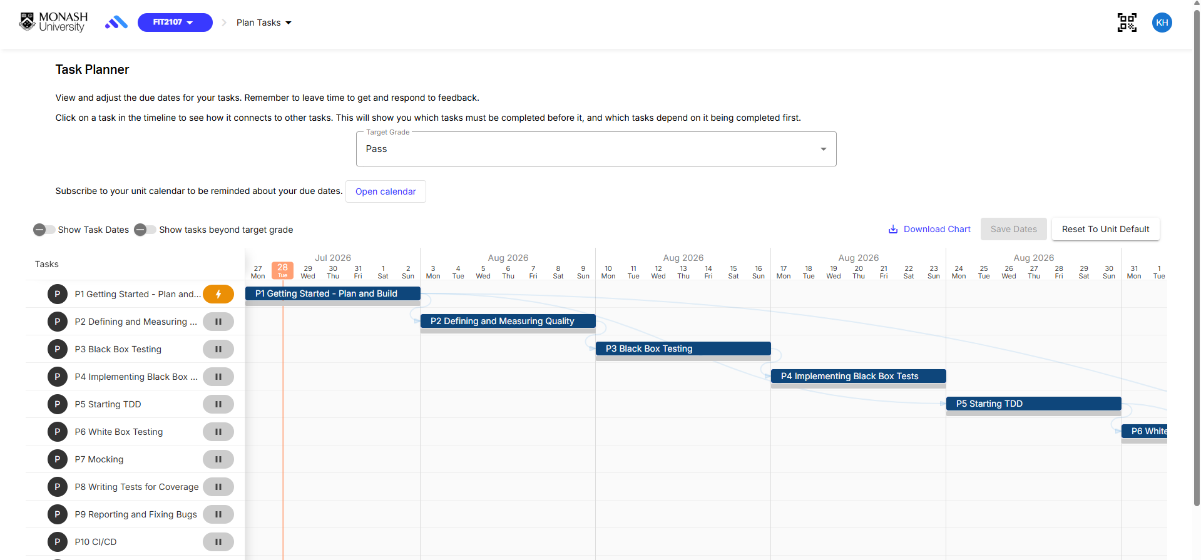

- Complete the declaration on the last page of this worksheet, under “I understand how this unit works”. Make sure you:
  - Add your name and student ID . OK
  - Tick the box next to each item to show that you have read, understood, and agree to it. OK
  - Add the date and your signature (just your name is fine) to the bottom. OK
- Watch the videos on Ed for Topic 1. OK
- Review the steps on Ed to get things installed and set up. OK
- Fill out the details in the README file of your repository. Add, commit, and push the changes to ensure your repository is working. Provide a screenshot of your repository in GitLab, showing your completed README:

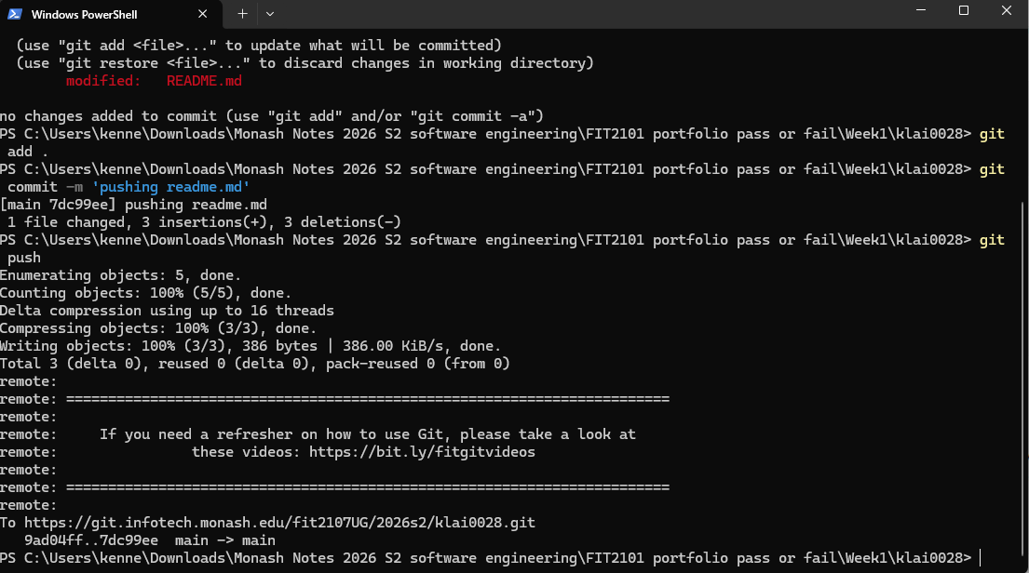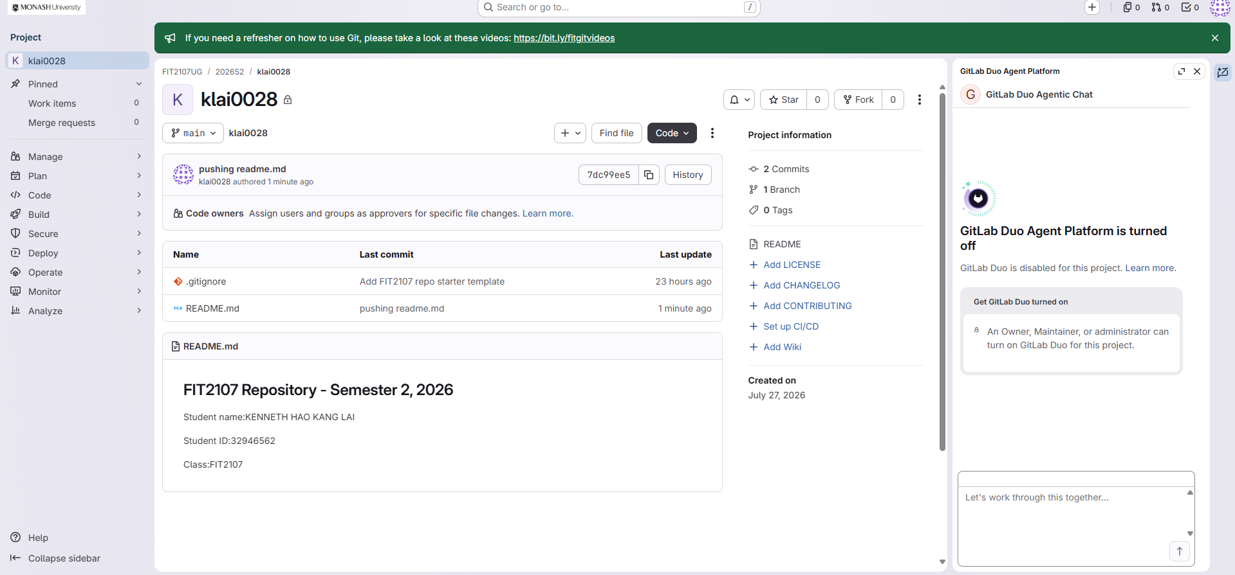

Reflect:
- What is your experience developing software in a local environment (i.e., not in EdStem), and how do you think you will go with this?
> I love command prompts , it give me full flexibility and able to deploy all my ideas

- Remembering to commit your work regularly can be quite challenging. What strategies are you going to put in place to help you do this?
My strategy is to commit every small changes in my local pc and push after a big changes

Disclose:
- Explain your use of Generative AI for this task. If you didn’t use it, you can just write “I did not use any AI for this task”. If you did use it, please state which AI model you used (e.g. ChatGPT) and how.

> I used chatgpt to help me on connecting my local folder with gitlab and pushing to the cloud.

Submit:
- Export this worksheet as a PDF.
- Upload your submission to OnTrack:
  - Mark the task as Ready for Feedback in OnTrack and upload the required files.
- Engage with feedback to get this signed off:
  - To get the task Complete, you need to engage with the feedback you receive. Your tutor will review your submission and may ask you to clarify aspects of the task or include aspects you have missed.
  - Remember, a Resubmit status is not a bad thing – your tutor is just trying to help improve your understanding. When you do resubmit, make sure to include a comment that describes what you changed. This needs to demonstrate how you have addressed all of your tutor’s feedback.
Tip: Initiate feedback
When you submit your work, you can add a comment to your tutor. It is a great idea to use this to ask for specific feedback on your work. This can help make sure you receive the most effective feedback to support your learning.

I understand how this unit works
I, KENNETH HAO KANG LA and 32946562, confirm that I have read and understood how this unit works: I understand that:
- I understand that my grade depends on the tasks I complete and the evidence I submit. I am responsible for ensuring my work demonstrates the required learning outcomes.
- I have reviewed the suggested task timeline and updated my learning plan in OnTrack. I will submit initial task attempts early enough to receive and act on feedback, and no later than the required deadlines.
- I will regularly check OnTrack deadlines and understand that missed deadlines may limit the grades I am eligible to achieve.
- I will respond to feedback, revise work where needed, and continue improving my submissions until the teaching team confirms that my work meets the required standards.
- I understand that feedback, including confirmation that my work meets the required standards, is available only up to each task’s latest due date in OnTrack. After that date, I am responsible for ensuring the task meets the required standard.
- I understand that I will need to discuss my work with the teaching team in the applied classes to validate and enhance my understanding of the concepts.
- I commit to working productively, collaboratively, and respectfully with the teaching team and other students, and agree that if I feel that any instructions are unclear I will proactively seek clarification from the teaching team. I will act in good faith according to the purpose of the task.
- I acknowledge that instructions, feedback, and clarifications provided by the teaching team form part of the learning process and are intended to support student learning, fairness, and the effective delivery of the unit. I will not rely on ambiguity, technicalities, or selective interpretations of instructions in a way that undermines the purpose of the task or the fairness of the learning environment.
- I understand I can escalate any concerns with the unit or formative feedback I have received through OnTrack to my TAs moderator. If I am not satisfied I can escalate my concerns further to the Chief Examiner or through the Monash complaints process.

Date: 28/07/2026
Signature:KEN

